Chapter 01 – Fundamentals of Waves
Lesson 01 – What Is a Sinusoidal Wave?

Question
What is a sinusoidal wave, and why is it considered the foundation of communication, radar, and beamforming systems?

Objective
After completing this lesson, the learner will be able to:
- Understand the concept of a sinusoidal wave.
- Explain why sinusoidal signals are fundamental in science and engineering.
- Identify the basic parameters of a sinusoidal waveform.
- Generate a sinusoidal signal using MATLAB.
- Interpret a simple time-domain waveform.

Background
Almost every field of electrical engineering begins with one simple waveform: the sinusoidal wave. At first glance, a sinusoidal waveform appears to be nothing more than a smooth oscillating curve. However, this simple mathematical function plays a central role in communications, radar, sonar, acoustics, control systems, electronics, medical imaging, and many other engineering disciplines.
Imagine a loudspeaker producing a pure musical tone. Although the sound itself cannot be seen, a microphone converts the pressure variations in the air into an electrical signal. When this signal is displayed as a function of time, it appears as a smooth periodic waveform known as a sinusoidal wave. Similarly, when an antenna transmits a single-frequency electromagnetic signal, the electric field oscillates sinusoidally as the wave propagates through space. Because sinusoidal waves naturally describe many physical phenomena, they have become the fundamental building blocks for signal analysis. An even more important reason for studying sinusoidal waves is provided by Fourier theory. Any physically realizable periodic signal can be represented as a combination of sinusoidal components with different frequencies, amplitudes, and phases. Consequently, understanding sinusoidal waves is equivalent to learning the basic language used in signal processing. For this reason, engineers do not begin by studying complex communication systems or advanced beamforming algorithms. Instead, they first learn how a single sinusoidal wave behaves. Once this concept is fully understood, more advanced topics such as interference, superposition, phase shift, time delay, antenna arrays, beamforming, MIMO systems, and Integrated Sensing and Communication (ISAC) become significantly easier to understand.
Throughout this educational project, every new concept will ultimately be built upon the principles introduced in this lesson. Therefore, this lesson should not be viewed as merely plotting a sine wave in MATLAB. Instead, it establishes the conceptual foundation upon which the entire Beamforming From First Principles Using MATLAB project is constructed.
Mathematics
After understanding the physical meaning of a sinusoidal wave, the next step is to describe it mathematically. A continuous-time sinusoidal signal can be represented as
$$x\left(t\right)=A\sin\left(2πft+ϕ\right)$$
where
- ($A$) is the amplitude of the signal,
- ($f$) is the frequency measured in Hertz (Hz),
- ($t$) represents time in seconds,
- ($ϕ$) is the initial phase measured in radians.
Although the equation appears simple, each parameter controls a different physical property of the waveform.
Amplitude
The amplitude determines the maximum value reached by the signal. Increasing the amplitude stretches the waveform vertically; while decreasing it compresses the waveform. Importantly, changing the amplitude does not affect the signal frequency or its oscillation speed. Mathematically,
$$\left|x\left(t\right)\right|≤A$$Therefore, the waveform always remains between
$$-A≤x\left(t\right)≤A$$
throughout time.

Frequency
The frequency specifies how many complete oscillations occur every second. Its unit is Hertz (Hz), where
$$1 \text{Hz}=1 \text{cycle per second}$$
Higher frequencies produce faster oscillations, whereas lower frequencies produce slower oscillations.
The period (T) and the frequency (f) are related by
$$T=\frac{1}{f}$$
For example,
- ($f=1$) Hz corresponds to a period of (1) second.
- ($f=5$) Hz corresponds to a period of (0.2) seconds.
- ($f=10$) Hz corresponds to a period of (0.1) seconds.

Time
Time is the independent variable of the waveform. As time progresses, the signal continuously changes according to the sinusoidal function. In MATLAB, time is represented using a uniformly sampled vector, allowing the waveform to be evaluated numerically.

Initial Phase
The initial phase determines where the waveform begins at time $t=0$. Changing the phase shifts the waveform horizontally without altering either its amplitude or its frequency. Since this lesson focuses only on generating a sinusoidal waveform, the initial phase is set to $ϕ=0$. The concept of phase will be studied in detail in a dedicated lesson later in this chapter.

Mathematical Interpretation
The sinusoidal equation may appear to describe only one waveform, but in reality it defines an entire family of signals. Different combinations of amplitude, frequency, and phase generate infinitely many sinusoidal waveforms. Therefore, the equation
$$x\left(t\right)=A\sin\left(2πft+ϕ\right)$$
should not be viewed merely as a mathematical expression. Instead, it serves as a compact model capable of representing a wide variety of physical signals encountered in engineering.
In this lesson, the equation is used only to generate a simple waveform. In the following lessons, each parameter will be investigated independently to understand its physical meaning and its influence on the resulting signal.

MATLAB Implementation
MATLAB is one of the most widely used software environments for scientific computing, signal processing, communications, radar, and beamforming research. Throughout this educational project, MATLAB will be used to transform mathematical equations into executable simulations.
The objective of this lesson is intentionally simple: generate a sinusoidal waveform and visualize it in the time domain.
Instead of writing code immediately after introducing the mathematical equation, it is helpful to first understand the logical sequence required to generate the waveform.
The implementation consists of five main steps.
Step 1 — Initialize the MATLAB Environment
The simulation begins by clearing the MATLAB workspace, command window, and previously opened figures.
This practice ensures that results from previous simulations do not affect the current lesson and improves reproducibility.

Step 2 — Define the Simulation Parameters
Next, all simulation parameters are defined in one location.
The parameters include:
- Signal amplitude
- Signal frequency
- Initial phase
- Sampling frequency
- Simulation duration
Grouping all parameters together makes the script easier to understand and allows future modifications without searching throughout the code.

Step 3 — Generate the Time Vector
A uniformly sampled time vector is created.
Rather than evaluating the mathematical equation at only a few points, MATLAB computes the signal at hundreds or thousands of equally spaced time instants.
This discrete representation allows a continuous-time waveform to be visualized on a digital computer.

Step 4 — Generate the Sinusoidal Signal
Using the mathematical model introduced earlier,
$x\left(t\right)=A\sin\left(2πft+ϕ\right)$,
MATLAB computes the signal value for every sample in the time vector.
The result is a vector containing the amplitude of the waveform at each instant of time.

Step 5 — Visualize the Waveform
Finally, the generated signal is plotted.
Although plotting may appear to be a simple step, visualization plays an essential role in engineering.
A properly formatted figure allows engineers to interpret signal behavior, verify simulation results, identify potential implementation errors, and communicate findings effectively.
For this reason, all figures in this project follow a consistent publication-quality style, including descriptive titles, labeled axes, readable fonts, grids, and high-resolution export options.

Implementation Philosophy
The MATLAB script developed in this lesson is intentionally simple.
Its purpose is not to demonstrate advanced programming techniques but to establish a clean, readable, and reusable coding style that will be followed throughout the entire project.
Every subsequent lesson will build upon this same structure, allowing learners to focus on understanding new concepts rather than adapting to different coding styles.
By maintaining a consistent implementation framework, the educational emphasis remains on learning signal processing concepts instead of learning new programming patterns in every lesson.

Visualization
The MATLAB implementation presented in this lesson generates a time-domain representation of a sinusoidal waveform.
The resulting figure illustrates how the signal amplitude changes continuously over time.
Unlike numerical values or mathematical equations, a graphical representation provides an intuitive understanding of signal behavior. Engineers often inspect signal plots before performing more advanced analyses because many important characteristics can be identified visually.
The generated figure should include the following elements:
- A descriptive figure title.
- Clearly labeled horizontal and vertical axes.
- Appropriate measurement units.
- A visible grid to improve readability.
- A line width suitable for publication-quality figures.
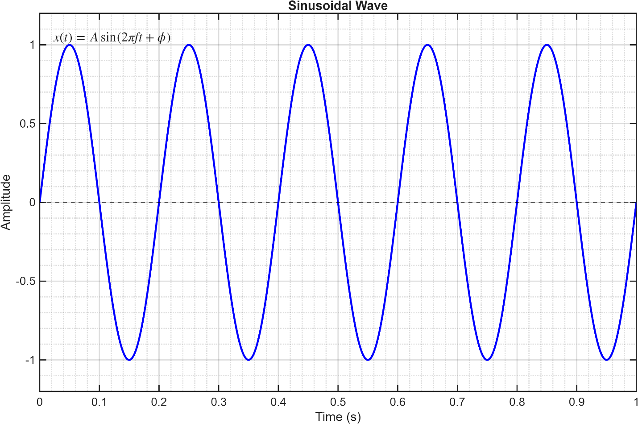
A typical output produced by the MATLAB script is shown in Figure 1.
Figure 1. Time-domain representation of a sinusoidal waveform generated using MATLAB.
From the figure, several important observations can be made.
First, the waveform repeats its shape at regular time intervals, indicating that it is a periodic signal.
Second, the signal oscillates symmetrically around zero, meaning that its positive and negative excursions have equal magnitude.
Finally, the waveform changes smoothly over time without discontinuities, which is one of the defining characteristics of sinusoidal signals.
The visualization presented in this lesson serves as the reference figure for many subsequent lessons throughout this project.

Discussion
Although the simulation performed in this lesson is intentionally simple, it establishes several important concepts that will be used repeatedly in later chapters.
The first observation is that a sinusoidal waveform is completely defined by only a small number of parameters. By modifying the amplitude, frequency, or phase, an entirely different waveform can be generated while preserving the same mathematical model.
The second observation is that mathematical equations become significantly easier to understand once they are visualized. Instead of treating the sinusoidal equation as an abstract expression, the learner can immediately observe how it produces a physical waveform.
Another important point is the relationship between mathematics and computation. The mathematical model describes the waveform analytically, whereas MATLAB evaluates that model numerically at discrete points in time. Consequently, the plotted signal is not the continuous waveform itself, but a discrete numerical approximation that accurately represents it when an appropriate sampling frequency is selected. This idea will become increasingly important in later lessons involving digital signal processing, beamforming algorithms, and radar simulations.
Finally, it is worth emphasizing that the purpose of this lesson is not to study every property of sinusoidal waves. Instead, this lesson establishes a common starting point for the remainder of the project.
Future lessons will investigate each parameter independently, beginning with amplitude, frequency, phase, time delay, and eventually leading to wave propagation, antenna arrays, and beamforming techniques.

Exercises
The following exercises are designed to reinforce the concepts introduced in this lesson. Before proceeding to the next lesson, learners are encouraged to complete these exercises using the provided MATLAB script.

Exercise 1 — Changing the Amplitude
Modify the signal amplitude while keeping all other parameters unchanged.
Perform the following simulations:
- ($A=0.5$)
- ($A=1$)
- ($A=2$)
Observe the resulting waveforms and answer the following questions:
- Which characteristic of the waveform changes?
- Does changing the amplitude affect the oscillation speed?
- Does the waveform remain periodic?

Exercise 2 — Changing the Frequency
Repeat the simulation using different frequencies.
For example,
- $\left(f=2\right)Hz$
- $\left(f=5\right)Hz$
- $\left(f=10\right)Hz$
Compare the resulting figures.
Describe how the waveform changes as the frequency increases.

Exercise 3 — Changing the Initial Phase
Modify the initial phase while keeping the amplitude and frequency constant.
Suggested values include
- $\left(0\right)$
- $\left(π/2\right)$
- $\left(π\right)$
Without performing any calculations, describe how the waveform changes visually.
The mathematical interpretation of phase will be discussed in a later lesson.

Exercise 4 — Increasing the Sampling Frequency
Increase the sampling frequency to a larger value.
Compare the new waveform with the original one.
Discuss how the sampling frequency influences the smoothness of the plotted signal.

Exercise 5 — Personal Exploration
Choose one simulation parameter and investigate its effect on the generated waveform.
Prepare a short paragraph summarizing your observations.

Key Takeaways
This lesson introduced the first and most fundamental signal encountered in communication and radar engineering: the sinusoidal wave.
The following concepts should now be understood.
- A sinusoidal wave is a smooth and periodic signal.
- Many engineering systems can be analyzed using sinusoidal waveforms.
- A sinusoidal signal is mathematically represented by
$x\left(t\right)=A\sin\left(2πft+ϕ\right)$.
- The waveform is described by four primary parameters:
  - Amplitude
  - Frequency
  - Time
  - Initial Phase
- MATLAB provides a simple and powerful environment for generating and visualizing sinusoidal signals.
- A clear visualization helps transform a mathematical equation into an intuitive physical concept.
Most importantly, this lesson establishes the conceptual foundation for every subsequent topic in this educational project.
The concepts introduced here will be revisited repeatedly when studying wave propagation, phase shift, time delay, antenna arrays, beamforming algorithms, direction-of-arrival estimation, MIMO systems, and Integrated Sensing and Communication (ISAC).
Understanding this lesson thoroughly will significantly simplify the study of all future chapters.

Looking Ahead
The next lesson will investigate one of the most important characteristics of a sinusoidal waveform:
Amplitude
Rather than simply defining amplitude mathematically, the next lesson will explore its physical meaning, visualization, and practical interpretation through MATLAB simulations.
Each subsequent lesson will build upon the knowledge established in this chapter, following the educational philosophy of this project:
Understand the concept, not memorize the equation.

